**R of NLP(JunJie Xie)**

1. Using the Federalist Papers Corpus, use R to create a labeled data frame and a matrix (either or both is fine – see the code for examples) with the words as the column names, the rows as each paper, and the data values as word counts.

1. Also print out the top 10 most frequent words.

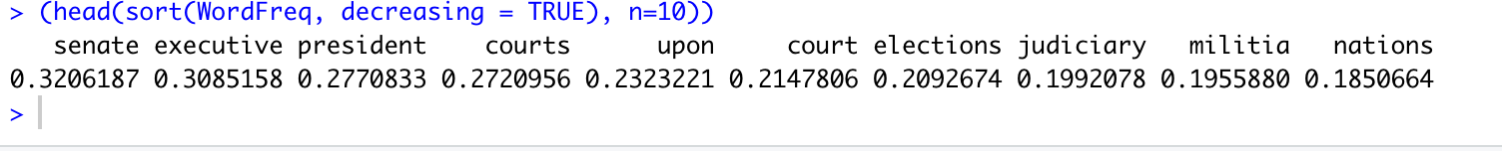

Maybe we can gas the theme of these articles from the most frequent words.

1. Print out the number of words in each document (after removing any stopwords like “and”, “but”, etc.)

1. Create a wordcloud for Hamilton and one wordcloud for Madison and compare them. What do they show and suggest?
2. Hamilton

I think these words standing for anger and defensiveness.

1. Madison

I think these words showing that the writer tries to provide some opinions and advices on trading. (maybe he is taking about the impact of international trade on domestic industries and workers? I gas.)